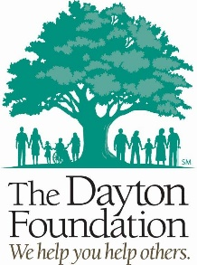

Audit Exemption Policy

For questions please contact Tania Arseculeratne, senior Community Engagement officer, at (937) 225-9966 or via email at tarseculeratne@daytonfoundation.org.

Organizations are required to submit their most recent audit when applying for a Dayton Foundation grant. The audit should be prepared by an independent and licensed certified public accountant. The financial transparency that an audit provides to funders and donors is a key element when evaluating an organization and a grant request.

The Dayton Foundation has adopted this audit policy with the following beliefs.

- An audit is a mark of responsibility, good stewardship and a message to donors.
- An audit builds the trust and confidence of financial supporters of the nonprofit by demonstrating best practices.
- An audit sets standards and procedures of fiscal responsibility throughout the organization.
- An audit provides the best assurances that gifts made with restrictions are consistently administered in accordance with the donors’ instructions.
- An audit protects the board, staff and volunteers of a nonprofit from unwarranted charges of careless or improper handling of funds.

Audit Exemption
If an organization does not have an audit, an Audit Exemption must be requested by answering the relevant question on the grants portal application.

If the organization has a financial review prepared by a licensed certified public accountant, the audit exemption question must be answered and the review submitted with the required documents on the portal.

An exemption may be granted under the following circumstances.

- A small organization with a budget less than $200,000
- A small organization that has completed a financial review
- Programs within a religious institution that use the accounting practices and reviews from national or regional religious offices
- A nonprofit facing an extenuating circumstance where an audit is not possible. The lack of financial resources for conducting an audit is not considered an acceptable reason for an exemption.

