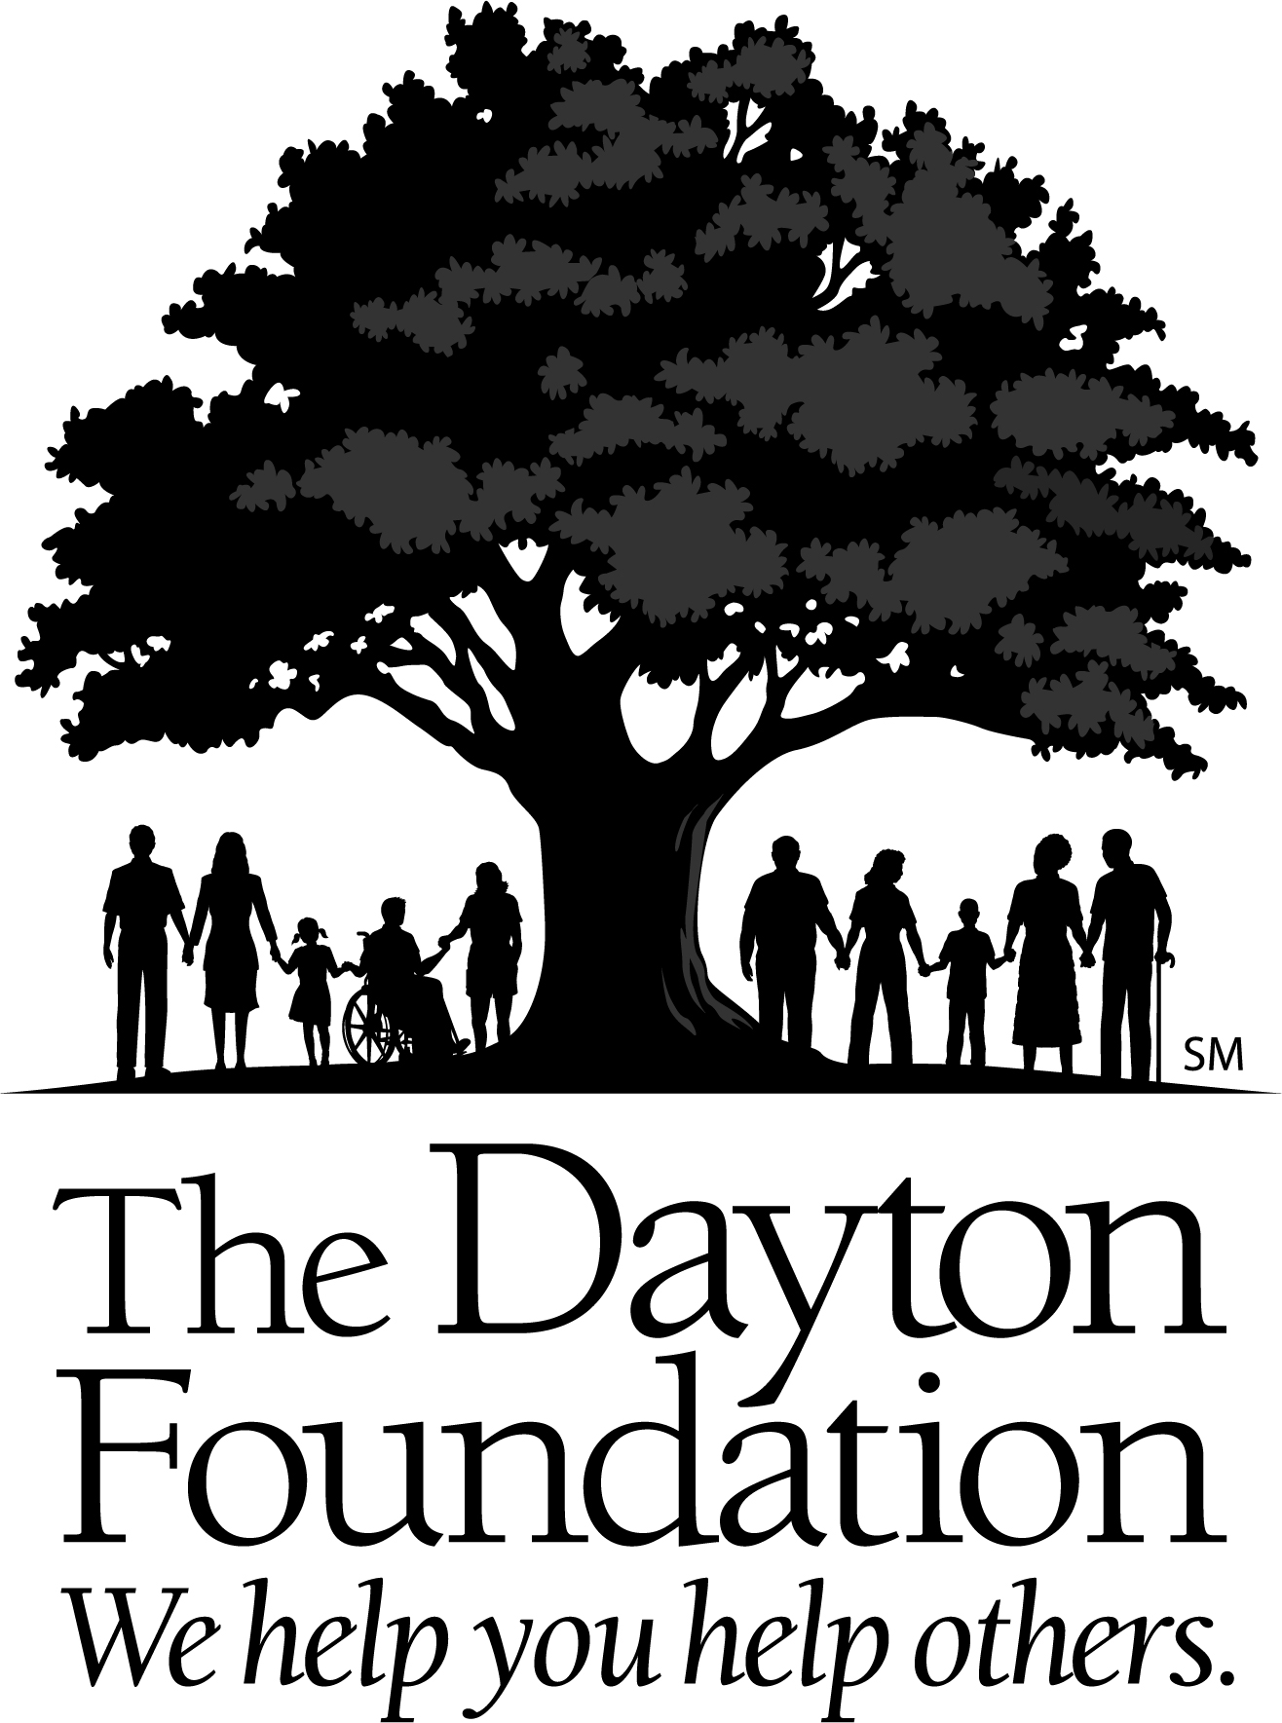

Application to Hold a Fund-Related Event

The Dayton Foundation is excited to assist you in your efforts to fundraise for your cause. Because your fund is a component fund of The Dayton Foundation, all events with proceeds that benefit your fund are subject to our Fundraising Policies and Procedures for Component Funds of The Dayton Foundation and Guidelines for Fund-Related Events. Completion of this form will allow us necessary oversight and ensure that your event runs as smoothly as possible.

If you have an established fund at The Dayton Foundation, and your event does not conflict with the requirements of your current fund, you may use your existing fund for your event at no additional charge.

If you need any of the additional event services listed below, you may open an Event Fund through The Dayton Foundation. The fee for an Event Fund is $750 per event. You will need an Event Fund if:

- You need a fund that has the capability of paying event expenses but is not an invested fund;
- You need acknowledgement letters for event registrants/attendees;
- You need acknowledgement letters for auction items or purchases; or
- The complexity of your event requires extra coordination from Foundation staff, either because of volume or the involvement of other organizations/entities.

Event Details
Name of Event:
Event Date: | Event Time: |  | Expected Attendance:
Event Location:
Contact Person:
Phone: | Email:
Tickets/Registrations? YES / NO | Price: | Deduction: ALL / NONE
Caterer? YES / NO | Company Name:
Alcohol? YES / NO | Liquor License Holder:
Sponsorships? YES / NO | Deduction: ALL / SPLIT (allowed deductions)
Event or Fund Website? YES / NO | Web address:
Third Party Event Site? YES / NO | Company Name:
Event transactions will be deposited into fund #:
— PLEASE TURN OVER —

By signing below you agree to the following:
- I understand that all fundraising events must follow local, state and national health guidelines regarding COVID - including self health checks for volunteers prior to the event, and masking and social distancing recommendations - and that event organizers and participants must follow stated protocols at the facility where the event is being held.
- I understand that I do not have the authority to enter into contracts for my fund. All contracts will be approved and signed by The Dayton Foundation.
- I understand that I may be required to provide additional documentation to The Dayton Foundation, such as liquor indemnity and certificate of insurance, prior to my event.
- I will submit this Application to Hold a Fund-Related Event to the Donor Relations Officer at least two months prior to the date of the event.
- I will use The Dayton Foundation deposit slip when turning in my event proceeds.
- I have read the Fundraising Policies and Procedures for Component Funds of The Dayton Foundation and the Guidelines for Fund-Related Events and agree to comply with the policies and procedures detailed therein.

Signature: | Date:

Contact the Foundation
If you have questions or need additional information about these policies, please contact:

Lucy Baker, Donor Relations Officer
The Dayton Foundation
1401 S. Main Street, Suite 100
Dayton, OH 45409
lbaker@daytonfoundation.org,
(937) 225-9960

